SSD for basic flows of **PlayGame** use case.

Basic Flow:

1. System gives turn to one player
2. System report movement to the player
3. Player proposes to move a piece (to the system) (THERE WILL BE A METHOD CALLED INSIDE ONE CLASS, A POPER NAME MUST BE DECLARED, MOVE OR PROPOSE MOVEMENT)
4. System executes movement (THRE IS NO ARROW IN THE DIAGRAM BECAUSE WE DO NOT SEE INTERACTION)
5. System notifies movement to the player
6. System records movement in trace (THERE IS NO ARROW IN THE DIAGRAM BECAUSE WE SEE NO INTERACTION)
7. System gives turn to the other player

Repeat steps 2 to 7 while there is no winner

1. System notifies winner to the player
2. System

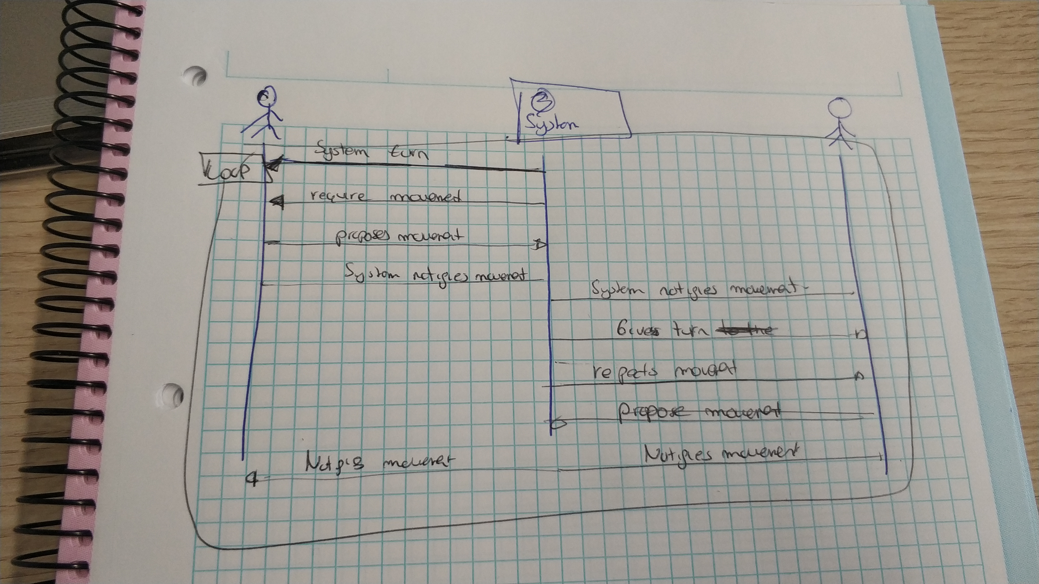

EXERCISE: add components to capture situation where the player on the left makes a movement and wins (put all the right part in a conditional frame) and would fully describe the exercise

Crucial point: To identify the most relevant interactions, player 🡪 system

Because this implies that in some class of the systems there shall be a method allowing the player to conduct such interaction by involving such the